TITLE : C Program to Initialize an Array Dynamically

EXP - 1

# PROGRAM :

**#include <stdio.h> int main()**

**{**

**int i,b;**

**printf("Enter The Size of the Array:"); scanf("%d",&b);**

**int a[b]; for(i=0;i<b;i++)**

**{**

**printf("Enter Element-%d:",i+1); scanf("%d",&a[i]);**

**}**

**printf("The Initialized Array:\n{ "); for(i=0;i<b;i++)**

**{**

**printf("%d ",a[i]);**

**}**

**printf("}");**

**}**

**INPUT AND OUTPUT** :

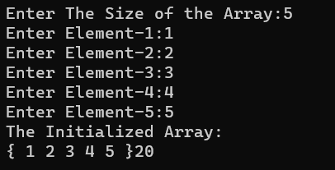

# RESULT :

The C Program for Initializing an Array Dynamically is Compiled and Executed

Using Dev-C++ and the Output is Verified.

TITLE : C Program to Find the Sum of Elements in the Given Array

EXP - 2

# PROGRAM :

**#include <stdio.h> int main()**

**{**

**int a[100],i,b,sum=0;**

**printf("Enter The Size of the Array:"); scanf("%d",&b);**

**for(i=0;i<b;i++)**

**{**

**printf("Enter Element-%d:",i+1); scanf("%d",&a[i]);**

**}**

**for(i=0;i<b;i++)**

**{**

**sum=sum+a[i];**

**}**

**printf("The Sum of Elements in an Array is:%d",sum);**

**}**

**INPUT AND OUTPUT** :

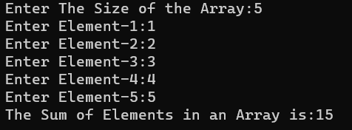

# RESULT :

The C Program for Finding the sum of Elements in an Array is Compiled and

Executed Using Dev-C++ and the Output is Verified.

TITLE : C Program to Find the Sum of Even and Odd Elements in the Given Array.

EXP - 3

# PROGRAM :

**#include <stdio.h> int main()**

**{**

**int a[100],i,b,esum=0,osum=0; printf("Enter The Size of the Array:"); scanf("%d",&b);**

**for(i=0;i<b;i++)**

**{**

**printf("Enter Element-%d:",i+1); scanf("%d",&a[i]);**

**}**

**for(i=0;i<b;i++)**

**{**

**if(a[i]%2==0)**

**{**

**esum=esum+a[i];**

**}**

**else**

**{**

**osum+=a[i];**

**}**

**}**

**printf("The Sum of Even Elements in an Array is:%d\n",esum); printf("The Sum of Odd Elements in an Array is:%d",osum);}**

**INPUT AND OUTPUT** :

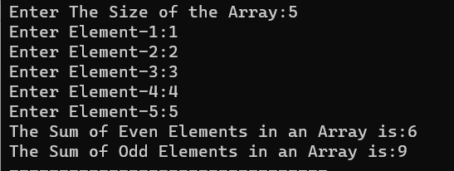

# RESULT :

The C Program for Finding the sum of Odd and Even Elements in an Array is

Compiled and Executed Using Dev-C++ and the Output is Verified.

TITLE : C Program to Perform Insertion and Deletion in an Array

EXP - 4

# PROGRAM :

**#include <stdio.h> #include <string.h> int main()**

**{**

**int a[100],i,j,t1,t2,b,c,e; char o[2];**

**printf("Enter The Size of the Array:"); scanf("%d",&b);**

**for(i=0;i<b;i++)**

**{**

**printf("Enter Element-%d:",i+1); scanf("%d",&a[i]);**

**}**

**while(true)**

**{**

**printf("Enter i for Insertion and d for Deletion:"); scanf("%s",o);**

**if(strcmp(o,"i")==0){**

**printf("Enter The Element to Insert:"); scanf("%d",&e);**

**printf("Enter The Position to Insert:"); scanf("%d",&c);**

**t1=a[c];**

**a[c]=e;**

**INPUT AND OUTPUT** :

b++;

for(i=c+1;i<b;i++)

{

t2=a[i];

a[i]=t1; t1=t2;

}

for(i=0;i<b;i++)

{

printf("%d ",a[i]);

}

printf("\n");

}

else if(strcmp(o,"d")==0)

{

printf("Enter the Element to be

Deleted:");

scanf("%d",&e); for(i=0;i<b;i++)

{

if(a[i]==e)

{

for(j=i;j<b;j++) {

a[j]=a[j+1];

}

b--;

}

}

for(i=0;i<b;i++)

{

printf("%d ",a[i]);

}

printf("\n");

}

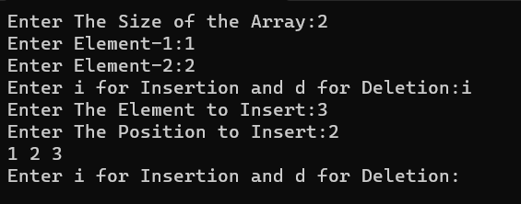

# RESULT :

The C Program for Performing Insertion and Deletion in an Array is Compiled and

Executed Using Dev-C++ and the Output is Verified.

**TITLE : C Program to Merge Two Arrays.**

EXP - 5

# PROGRAM :

**#include <stdio.h> int main()**

**{**

**int a[100],b[100],i,c,d,j=0;**

**printf("Enter The Size of First Array:"); scanf("%d",&c);**

**printf("Enter The Size of Second Array:"); scanf("%d",&d);**

**printf("Enter The Elements into the 1st Array\n");**

**for(i=0;i<c;i++)**

**{**

**printf("Enter Element-%d:",i+1); scanf("%d",&a[i]);**

**}**

**printf("Enter The Elements into the 2nd Array\n");**

**for(i=0;i<d;i++)**

**{**

**printf("Enter Element-%d:",i+1); scanf("%d",&b[i]);**

**}**

**for(i=c;i<c+d;i++)**

**{**

**a[i]=b[j]; j++;**

**}**

**printf("The Merged Array:\n{"); for(i=0;i<c+d;i++)**

**{**

**if(i<c+d-1)**

**{**

**printf("%d,",a[i]);**

**}**

**else**

**{**

**printf("%d}",a[i]);**

**}**

**}**

**}**

**INPUT AND OUTPUT** :

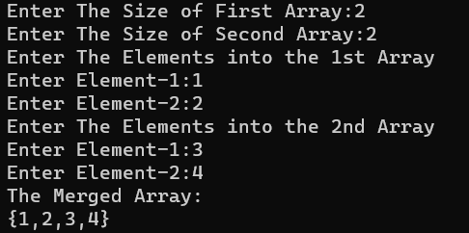

# RESULT :

The C Program for Merging Two Arrays is Compiled and Executed Using Dev-C++

and the Output is Verified.

TITLE : C Program to Find Duplicate Value in an Array

EXP - 6

# PROGRAM :

**#include <stdio.h> int main()**

**{**

**int a[100],b,i,c,d=0,j[100]; printf("Enter The Size of the Array:"); scanf("%d",&b);**

**for(i=0;i<b;i++)**

**{**

**printf("Enter Element-%d:",i+1); scanf("%d",&a[i]);**

**}**

**printf("Enter The Search its Duplicate:"); scanf("%d",&c);**

**for(i=0;i<b;i++)**

**{**

**if(c==a[i])**

**{**

**j[d]=i; d++;**

**}**

**}**

**printf("The %d Duplicate(s) are Present in Index Positions : ",d-1);**

**for(i=1;i<d;i++)**

**{**

**printf("%d ",j[i]);**

**}**

**}**

**INPUT AND OUTPUT** :

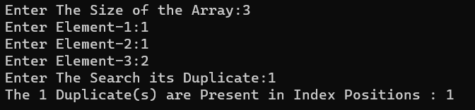

# RESULT :

The C Program for finding the duplicate values is Compiled and Executed Using

Dev-C++ and the Output is Verified.

TITLE : C Program to Find Largest Element in an Array.

EXP - 7

# PROGRAM :

**#include <stdio.h> int main()**

**{**

**int a[100],b,max=0,i;**

**printf("Enter The Size of the Array:"); scanf("%d",&b);**

**for(i=0;i<b;i++)**

**{**

**printf("Enter Element-%d:",i+1); scanf("%d",&a[i]);**

**}**

**max=0; for(i=0;i<b;i++)**

**{**

**if(a[i]>max)**

**{**

**max=a[i];**

**}**

**}**

**printf("The Largest Element in the array is %d",max);**

**}**

**INPUT AND OUTPUT** :

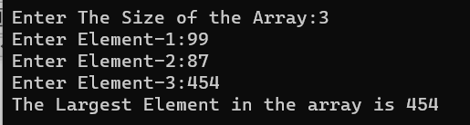

# RESULT :

The C Program for finding the largest Number in an Array is Compiled and

Executed Using Dev-C++ and the Output is Verified.

TITLE : C Program to Search an Element in an array using linear search.

EXP - 8

# PROGRAM :

**#include <stdio.h> int main()**

**{**

**int a[100],b,c,j=0,i;**

**printf("Enter The Size of the Array:"); scanf("%d",&b);**

**for(i=0;i<b;i++)**

**{**

**printf("Enter Element-%d:",i+1); scanf("%d",&a[i]);**

**}**

**printf("Enter The Element to be Searched:"); scanf("%d",&c);**

**for(i=0;i<b;i++)**

**{**

**if(a[i]==c)**

**{**

**printf("Element found at %d index",i); j++;**

**break;**

**}**

**}**

**if(j==0)**

**{**

**printf("Element Not**

**found");**

**}**

**}**

**INPUT AND OUTPUT** :

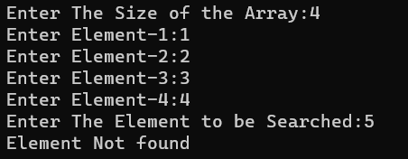

# RESULT :

The C Program for finding an element in an Array Using Linear Search is Compiled

and Executed Using Dev-C++ and the Output is Verified.

TITLE : C Program to Search an Element in an array using Binary search.

EXP - 9

# PROGRAM :

|  |  |  |  |
| --- | --- | --- | --- |
| **#include <stdio.h>** |  | **{** |  |
| **int main()** |  |  | **m=(l+h)/2;** |
| **{** |  |  | **if(a[m]==e)** |
| **int a[100],l,m,h,b,e,f=0,i;** |  |  | **{** |
| **printf("Enter The Size of the Array:");** |  |  | **f=1;** |
| **scanf("%d",&b); for(i=0;i<b;i++)**  **{**  **printf("Enter Element-%d:",i+1); scanf("%d",&a[i]);**  **}**  **printf("Enter The Element to be Searched For:"); scanf("%d",&e);**  **l=0;**  **h=l-1; while(f!=1)**  **{**  **m=(l+h)/2; if(a[m]==e)**  **{**  **f=1;** |  | **printf("Element**  **Found at %d index",m);**  **break;**  **}**  **else if(e>a[m])**  **{**  **l=m;**  **}**  **else**  **{**  **h=m;**  **}**  **}**  **}** | |

**INPUT AND OUTPUT** :

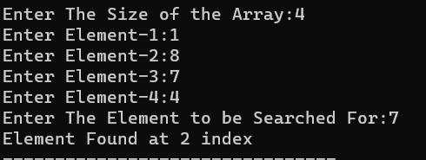

# RESULT :

The C Program for finding an element in an Array Using Binary Search is

Compiled and Executed Using Dev-C++ and the Output is Verified.

TITLE : C Program to Check The Given String is Palindrome or Not.

# PROGRAM :

EXP - 10

**#include <stdio.h> #include <string.h> int main()**

**{**

**char a[100],b[100]; int i,j=0;**

**printf("Enter The String:"); scanf("%s",a); for(i=strlen(a)-1;i>=0;i--)**

**{**

**b[j]=a[i]; j++;**

**}**

**if(strcmp(a,b)==0)**

**{**

**printf("The String is a Palindrome");**

**}**

**else**

**{**

**printf("The String is not a Palindrome");**

**}}**

**INPUT AND OUTPUT** :

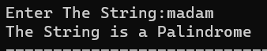

# RESULT :

The C Program for Checking a Given String is Palindrome or not is Compiled and

Executed Using Dev-C++ and the Output is Verified.

TITLE : C Program for Matrix Multiplication.

# PROGRAM :

**#include <stdio.h> int main()**

**{**

**int a[10][10],b[10][10],c[10][10];**

**int i,j,k,l;**

**printf("Enter No of Rows in the Matrix:"); scanf("%d",&l);**

**printf("Enter First Matrix of Order %dx%d\n",l,l); for(i=0;i<l;i++)**

**{**

**for(j=0;j<l;j++)**

**{**

**scanf("%d",&a[i][j]);**

**}**

**}**

**printf("Enter Second Matrix of Order %dx%d\n",l,l); for(i=0;i<l;i++)**

**{**

**for(j=0;j<l;j++)**

**{**

**scanf("%d",&b[i][j]);**

**}}**

**printf("The Resultant Matrix:\n"); for(i=0;i<l;i++)**

**{**

**for(j=0;j<l;j++)**

**{**

**c[i][j]=0; for(k=0;k<l;k++)**

**{**

**c[i][j]+=a[i][k]*b[k][j];**

**}**

**}**

**}**

**for(i=0;i<l;i++)**

**{**

**for(j=0;j<l;j++)**

**{**

**printf("%d ",c[i][j]);**

**}**

**printf("\n");**

**}**

**}**

**INPUT AND OUTPUT** :

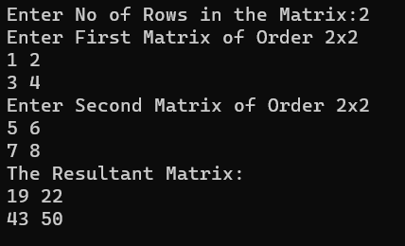

# RESULT :

The C Program for performing matrix multiplication is Compiled and Executed

Using Dev-C++ and the Output is Verified.